PROJECT DEVELOPMENT PHASE 2
Access Rule Analysis & Planning
Script-Controlled ACL – Restrict Record Access Based on Field Value
Project Details | Values
Date | 30 September 2026
Team ID | SWTID-2026-8983
Project Name | Script-Controlled ACL – Restrict Record Access Based on Field Value
Phase | Phase 2 – Access Rule Analysis & Planning
Maximum Marks | 5 Marks

Team Role | Team Member
Team Leader | NITHYA SREE S
Team Member | RAMASRI D
Team Member | PRATHISHA S
Team Member | MEGALA M
Team Member | MANJARI T

1. Objective
Convert the requirements into a clear access matrix and plan the ACL behavior before configuration.

2. Phase Workflow
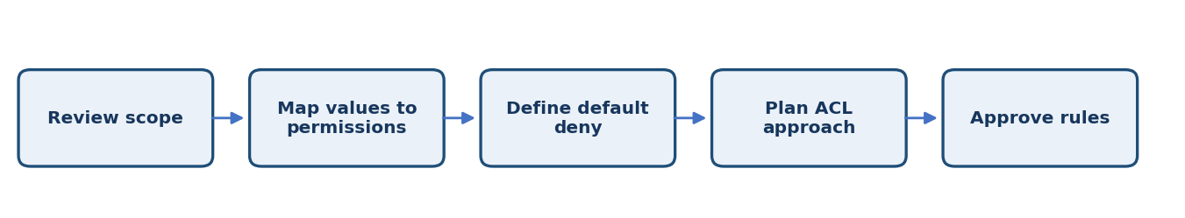

3. Activities / Scope
- Define allowed field values (example: Public, Internal, Restricted).
- Map each field value to approved roles or ownership rules.
- Decide whether access is controlled at table/record level or field level.
- Define default-deny behavior for blank or unexpected values.
- Prepare backlog, sprint estimates, risks, and dependencies.

4. Sprint Backlog & Estimation
Sprint | Story ID | Requirement | User Story / Task | Story Points | Priority | Team Members
Sprint 2 | US-201 | Create access matrix | Map field values to users, roles, and expected access. | 3 | High | Project Team
Sprint 2 | US-202 | Plan ACL approach | Select Read ACL and identify required conditions/roles. | 2 | Medium | Project Team
Sprint 2 | US-203 | Plan test cases | Prepare positive, negative, and edge-case scenarios. | 2 | Medium | Project Team

Total Estimated Story Points: 7

5. Testing / Review Template
Test Case ID | Scenario / Steps | Expected Result | Actual Result | Status
TC-01 | Walk through every access-matrix row and verify that the rule is unambiguous and testable. | Expected behavior matches approved requirement. | ________________ | Pass / Fail
TC-02 | Record observations, issues, and evidence for this phase. | No unresolved blocker before phase sign-off. | ________________ | Pass / Fail
TC-03 | Review phase deliverables with the responsible team member. | Deliverables reviewed and approved. | ________________ | Pass / Fail

6. Deliverables
- Field-value access matrix
- ACL implementation plan
- Sprint backlog and risk list

7. Team Review & Sign-off
Review Item | Details
Prepared by | Megala M / Project Team
Reviewed by | ____________________________
Approval / Date | ____________________________
Remarks | ________________________________________________

